Part e
Through this script it creates an inline table valued function called fnGetFavoriteTableStats which joins the Reservations table with the Customers table to take the customers names. Then it compares the PrefferedTableID with the ActualTableID for each reservation. This script also uses a CASE statement to generate either Yes or No flag in the GotFavoriteTable column which shows whether the customer has or hasn’t received the favorite table.
There are two tests which execute two SELECT statements, the first test gets a detailed list of all the reservations with their status, and the second test uses an aggregate function COUNT () and a GROUP BY clause in order to calculate the number of customers who did and didn’t receive their favorite table.

Successfully creation of the function
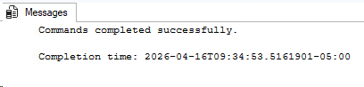

Test 1
Displays the full list of the reservations which shows each customers preferred table and the table which is actually assigned and a status as yes or no to show whether they are been matched.
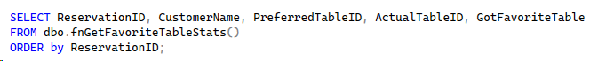
Results
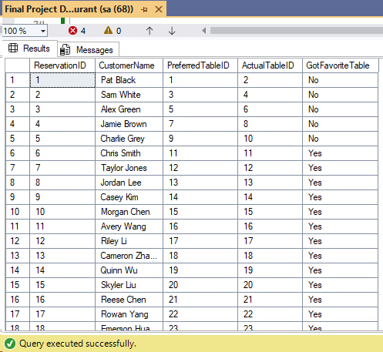
Test 2

The results are being aggregated in order to count how many customers did receive their preferred table and who didn't in total.
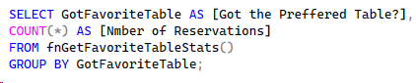
Results
